Orientation and Mobility Specialist
Expression of Interest

- Opportunities await experienced O&M’s to join our teams across Australia
- Based in either NSW, VIC, QLD or WA
- Full-time and part-time opportunities available
- $83,881 starting salary + Super + Salary Packaging
Do you want to make a difference and become a part of a team that supports a future where people who are blind or have low vision can live an independent life they choose?
If so, then this might be the perfect role for you!
About us
Vision Australia is a leading national provider of blindness and low vision services in Australia. We work in partnership with Australians who are blind or who have low vision to achieve the possibilities they choose in life.

About who we support
Vision Australia provides services to more than 25,500 people clients from 35 Vision Australia centres in Victoria, New South Wales, the Australian Capital Territory, Queensland, South Australia and Western Australia; and through outreach programs in the Northern Territory and Tasmania.

About the role
- Assess the ability of clients to travel safely and confidently within area of the community they wish to access;
- Advise on and prescribe a range of mobility aids and provide specialist services to meet individual needs;
- Monitor and advise on the use of low vision aids as applicable to a mobility program;
- In consultation with clients, plan, develop, deliver and evaluate individual or group specialised services in line with clients’ needs identified throughout the assessment process;
About you
To be successful in this role you will have:
- Approved qualifications in O&M as recognised by Orientation and Mobility Association Australasia (OMAA);
- Knowledge and skills in working with children, adults and older adults;
- Demonstrated specialty in Paediatrics Orientation and Mobility would be beneficial;
- Experience in providing client support and O&M services in person and/or through other communication mediums;
- Training and intervention strategies for individuals and groups;
- Strong planning skills including sound time management skills.
Benefits of working at Vision Australia
- Generous salary packaging options
- Flexible working arrangements
- Exciting career paths
- Exceptional professional development opportunities
To apply

If this sounds like a great fit for you then please email or contact the below:

Michele Hovey – People & Culture Business Partner
- Michele.Hovey@visionaustralia.org
- 0431 224 766

Bianca Fox – People & Culture Advisor
- Bianca.Fox@visionaustralia.org
- 0410 611 409
Applications should consist of a full resume and a cover letter.
For more information about working at Vision Australia go to www.visionaustralia.org/careers
We highly encourage applications from candidates who are blind or have low vision.

Position Description

Orientation and Mobility Specialist
Vision Australia, supporting people who are blind or have low vision to live the life they choose.

Purpose of Position
The key purpose of this position, in consultation with the client, is to utilise knowledge and skills to provide assessment, training, intervention and service co-ordination to assist in achieving equity and access for people who are blind or have low vision. Orientation and Mobility (O&M) services are provided to clients of all ages, carers and families.

Context
Vision Australia exists to support people who are blind or have low vision to live the life they choose. Vision Australia provides services to more than 25,500 people clients from 35 Vision Australia centres in Victoria, New South Wales, the Australian Capital Territory, Queensland, South Australia and Western Australia; and through outreach programs in the Northern Territory and Tasmania.

Principle Responsibilities
- Assess the ability of clients to travel safely and confidently within area of the community they wish to access;
- Advise on and prescribe a range of mobility aids and provide specialist services to meet individual needs;
- Monitor and advise on the use of low vision aids as applicable to a mobility program;
- In consultation with clients, plan, develop, deliver and evaluate individual or group specialised services in line with clients’ needs identified throughout the assessment process;
- As required, act as the Primary Service Provider to coordinate the provision of services internally to clients and families and to liaise with external service providers to achieve desired outcomes for clients;
- Identify, develop and review information and resources; promote and represent Vision Australia regarding O&M issues in relevant forums; develop and maintain internal and external networks;
- Provide professional development as appropriate to relevant parties;
- Monitor and maintain accurate, up to date client records in accordance with professional standards, Vision Australia policy and procedures and other relevant legislation including Disability Act;
- Continuous professional development including keeping up to date with new research and maintaining skills & knowledge level;
- Support student supervision and collaboration with learning institutions universities e.g. universities, peak bodies;
- Other duties as required by the Regional Client Services Manager;
- Assist with maintaining a high standard of safety at Vision Australia by following all safety procedures at all times and acting safely, not putting yourself or other people at risk by your actions or omissions. Ensure that all work performed is in accordance with Vision Australia policies & procedures.

Key Performance Indicators
Key performance indicators will be clearly defined through the performance planning process.

Essential Job Competencies
- Approved qualifications in O&M as recognised by Orientation and Mobility Association Australasia (OMAA);
- Knowledge and skills in working with children, adults and older adults;
- Experience in providing client support and O&M services in person and/or through other communication mediums;
- Training and intervention strategies for individuals and groups;
- Strong planning skills including sound time management skills;
- Well-developed analytical and problem solving skills;
- Ability to work as part of a team and independently as required;
- Ability in establishing and building positive working relationships at all levels;
- Excellent interpersonal and written communication skills;
- Computer literacy skills in Microsoft applications and the internet;
- Empathy and emotional maturity;
- Ability to adapt to changes in the work environment;
- An understanding of the impact of blindness and low vision (desirable);
- Experience working with families from culturally and linguistically diverse backgrounds (desirable).

Organisational Values
The expectation that we set is that our workforce understands and models our values and behaviours in everything they do 100% of the time;
- Person-Centred - We measure our success in terms of outcomes for our clients;
- Accountable - We hold ourselves responsible for what we do and don’t do;
- Collaborative - We work well together and with others to deliver the best possible outcomes;
- Commercially Focussed - We work efficiently and responsibly to sustain and grow our services and influence;
- Agile - We will adapt, learn and innovate to have a positive impact in a changing environment.

Vision Australia environment
Many Vision Australia employees work with Seeing Eye Dogs and all employees are likely to have contact with working dogs.
Employment is subject to the Organisation receiving a National Police Record Check and a Working with Children Check or QLD Blue Card or Vulnerable Persons (ACT) check.

Role Scope
Reports to: Regional Client Services Manager
Direct Report Staff: 0
In-Direct Report Staff: 0

Review of Job Description
This job description will be reviewed in line with the performance planning and appraisal process.
END OF POSITION DESCRIPTION.

Careers at
Vision Australia

Prospectus

About Vision Australia
Vision Australia has grown and evolved since it began nearly 150 years ago. Today Vision Australia is a national provider of disability services that support people who are blind or have low vision to live the life they choose.
Our passion for putting people who are blind or have low vision is at the centre of everything we do. This approach is essential to the human rights of every individual we support and also to the future of our organisation.
Over 26,000 people receive services from 30 Vision Australia Centres across every State and Territory in Australia. Innovative telehealth technology makes it possible for clients and their families to connect with us regardless of where they live. Even in regional and remote locations we are delivering high quality services and support into clients’ homes.
The blindness and low vision community still face challenges within everyday society; whether it’s not being able to enjoy free-to-air television with their family because audio-description services are not offered or their job is threatened due to their vision impairment.
Vision Australia takes on these challenges at an individual and societal level to influence positive change. Working with government and industry, we stand alongside our community and add our influence and voice to issues that matter.

Supporting people who are blind or have low vision at every stage of their life
Our mission is very clear. We exist to support people who are blind or low vision to live the life they choose.
Vision Australia’s workforce specialises in blindness and low vision services and works one-on-one with clients to develop and deliver a range of services and supports based on their own goals and aspirations.
Service provision is based around a lifetime of support that has a measurable impact in the education, employment, independence and social inclusion for people who are blind or have low vision. Each of these areas is inseparably linked and our clients can achieve great outcomes with our help.
Passionate, committed and highly skilled health professionals work with clients across a number of services including:
- Allied health services specialising in blindness and low vision across a range of disciplines such as Orthoptics, Optometry, Occupational Therapy and Orientation and Mobility.
- Community and recreation groups, events and activities, online forums and social media communities.
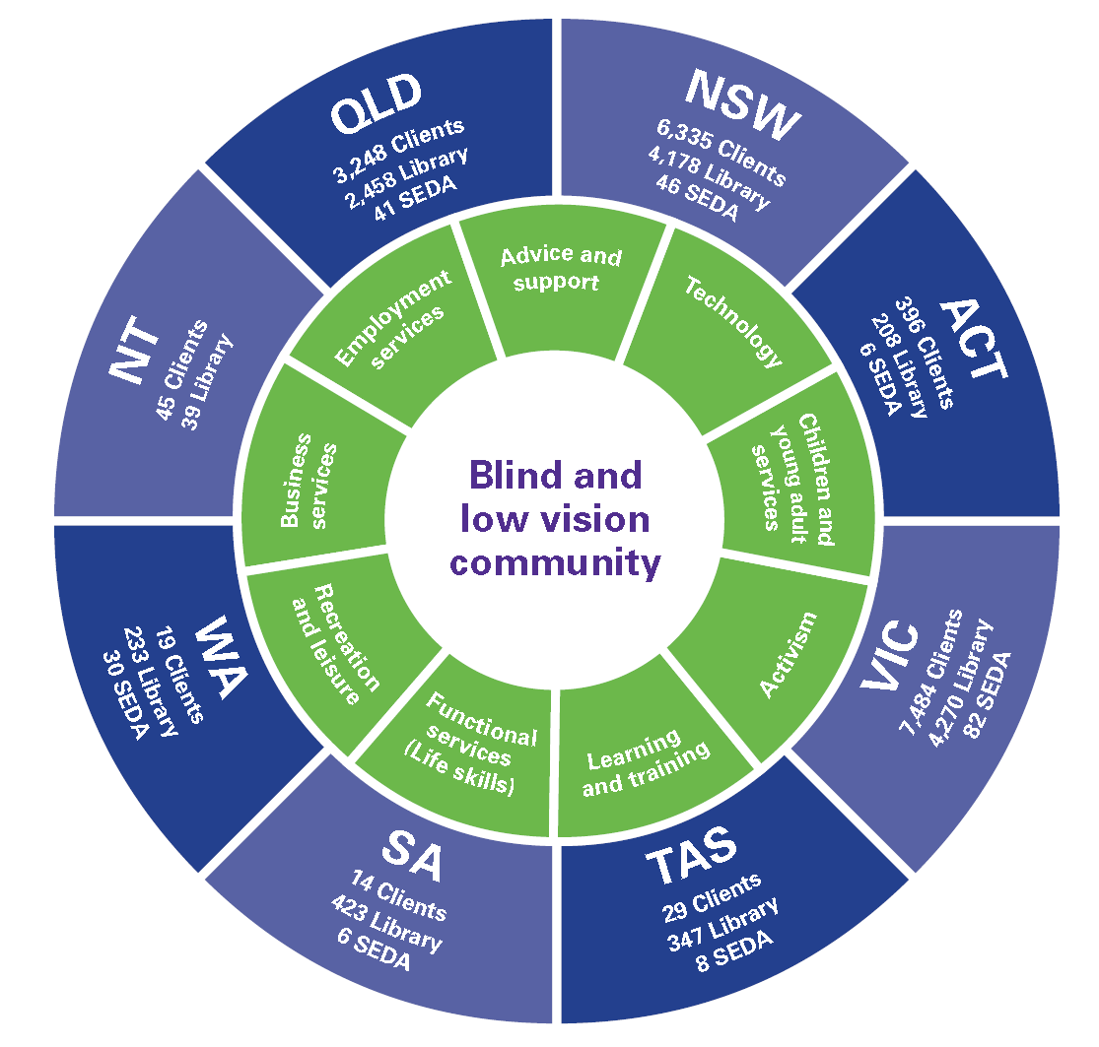
- Quality living groups and peer support programs that facilitate learning and shared experiences.
- Client and carer advocacy representation at an individual and systemic level
- Employment services including career development
- Technology services specialists with experience in supporting clients to use assistive technology
- Seeing Eye Dog training to international best practice standards.
Our front-line employees rely on the expertise of over 350 people in support roles who provide IT infrastructure, product development, marketing, fundraising, finance, digital and product development.
And whether it’s reading the news headlines on the Vision Australia radio, caring for Seeing Eye Dog puppies or preparing reading material for library members, we couldn’t achieve great outcomes for our clients without the support of over 2,600 active volunteers.

Our People live by Vision Australia’s values
Our values define us and drive the way we interact with each other and our clients.
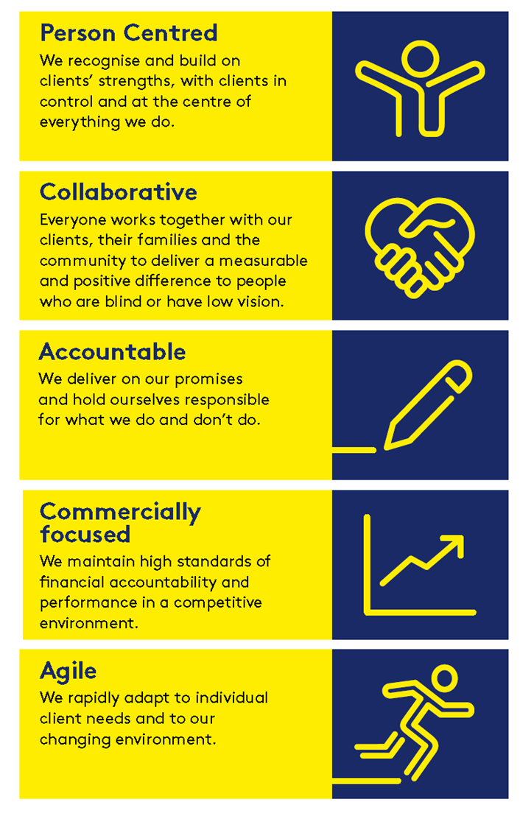

Vision Australia’s commitment to its workforce
Our strength lies in the diversity of our workplace. We have an inclusive culture and value diversity and all abilities. We recognise that our workforce (paid and volunteer) are the heart of our culture. It’s already a great place to work, and we continue to work together to make it even greater by:
- Creating a flexible and positive work environment so our people can deliver exceptional client outcomes
- A focus on performance so our people can successfully contribute to the strategic objectives of the organisation
- Investing in capability to ensure we meet the current and future needs of the business and the aspirations of our people.
- Clinical supervision and support to build the capacity of individual service providers from a dynamic, strengths-based, coaching approach.

