15 July 2025

# Attention: OMAA Members, NDIA Plan Managers and other stakeholders

Response from Orientation and Mobility Association of Australasia Professional Standards Committee to NDIA July 2025 Price Guide

The Orientation and Mobility Association of Australasia (OMAA) is the registration body for Orientation and Mobility (O&M) Specialists in Australia. The Professional Standards Committee (PSC) of OMAA gathers voices from a range of stakeholders and informs OMAA direction on management of standards of practice in the profession of O&M, and reports to the Executive Committee.

## Registered O&M Specialist in Australasia (ROMSA)

Registered members are ordinary members of the Association who have also passed the international examination for Certified Orientation and Mobility Specialists and who meet any additional requirements for registration, as set from time to time by the Executive. This is constitutionally defined and remains unchanged.

The definition of O&M Specialist was introduced in the verification module in March 2025. Orientation and Mobility Specialists can continue to claim as “Other Professionals” as listed on page 93 of the July 2025 Price Guide.

This is supported by the NDIA Quality and Safeguards Commission Verification Module page 18. One can search the OMAA Directory to see if you or the O&M Specialists in question has a Registered Membership.

<https://www.ndiscommission.gov.au/rules-and-standards/ndis-practice-standards/verification-module>

<https://www.ndis.gov.au/providers/pricing-arrangements>

We are seeking clarification of what the changes to the Verification Module mean to our membership. Teresa Gorondi from the NDIS Quality and Safeguard Commission is currently supporting OMAA to secure answers from NDIA as a matter of urgency.

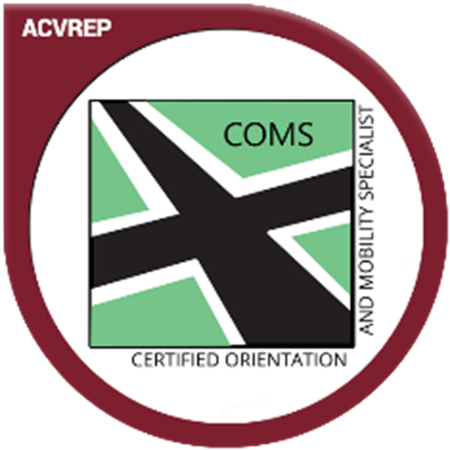

Felicity Gates ROMSA

Orientation and Mobility Association of Australasia

Chair, Professional Standards Committee