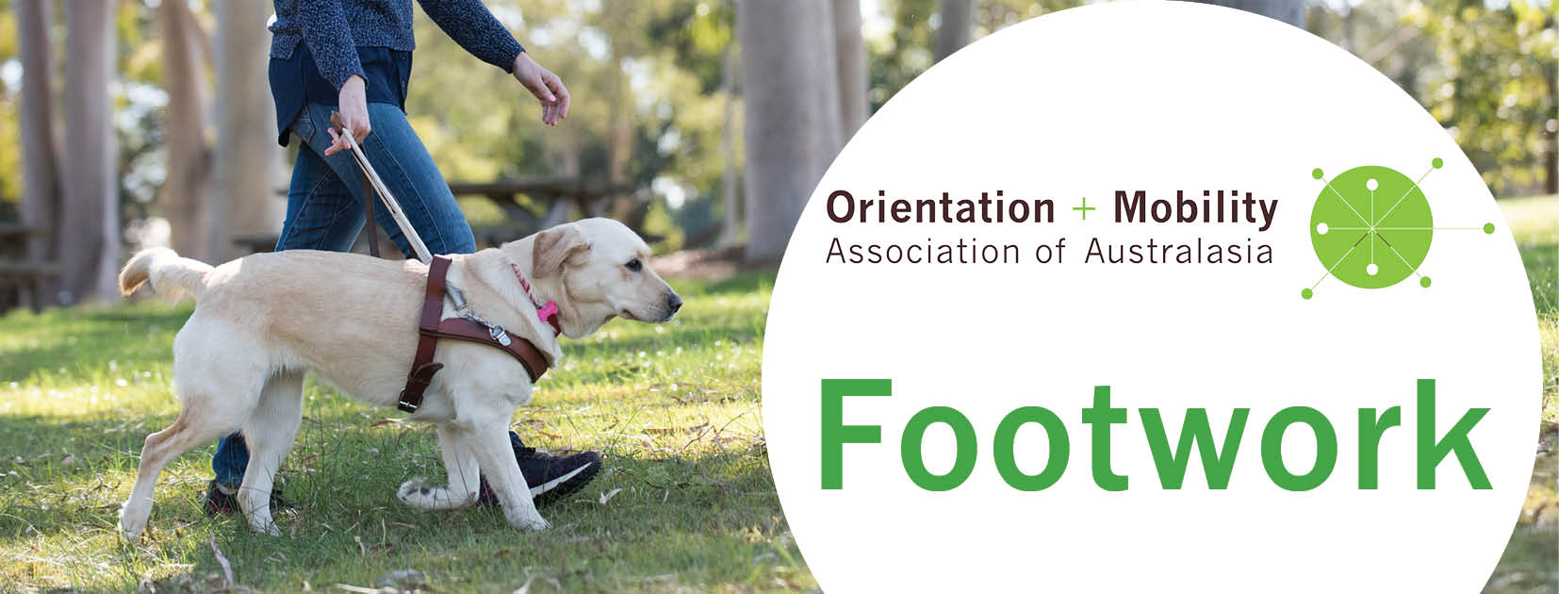
Issue 8, May 2020

Welcome to Footwork, keeping you informed of developments in the Orientation and Mobility Association of Australasia (OMAA).

OMAA Online Symposium 2020 - Scholarship
Even before the Coronavirus lockdown, the Professional Development team began planning our first OMAA Online Symposium for 22 September 2020. Put it in your diary! The symposium is an opportunity to bring our profession across Australasia together to share what makes our O&M practice unique to our part of the world. This one-day event is a great way to make O&M professional development more accessible, and attendees will earn points towards COMS recertification.
OMAA is also offering two scholarships to pay for registration fees. At the end of this edition of Footwork there is a one-page attachment describing the scholarship and how to apply. Applications open at the start of June.

Coronavirus (COVID-19)
The OMAA takes the threat of Coronavirus (COVID-19) seriously and is concerned for the health and wellbeing of OMAA members and clients. The COVID-19 situation continues to evolve on a daily basis and varies across countries, therefore OMAA recommends that members stay up to date with information and advice from national (NZ) or state and federal (AUS) government authorities. In addition, the World Health Organisation provides regular and reliable updates, advice and recommendations for protective measures. OMAA strongly recommends that all members continue to follow these protective measures.
Members employed by agencies need to follow the COVID-19 policies and procedures put in place by their employer. Independent service providers will need to develop and adhere to processes that are in line with national or state and federal government information, advice and directives in relation to protective measures, travel, social distancing, and self-isolation, as applicable.

The O&M Profession in ANZ
The OMAA’s last O&M census in 2011 indicated a total of 248 O&M specialists working in Australia/New Zealand, including 63 guide dog mobility instructors. These numbers might have dropped recently, and we are planning another census in 2021 to gather more accurate information.
During the same decade, OMAA membership has doubled and we now have 146 OMAA members. Most are Ordinary Members – qualified O&M specialists working in the industry, but we also have some Associate/Affiliate Members who are students or supporters of O&M from other professions.
Ordinary Members can apply for international certification through the COMS program. In the past year we have increased from 8 COMS to 62 COMS in Australia and New Zealand, and numbers are rising.
Ordinary members with COMS are eligible for OMAA registration. So far, we have 34 Registered O&M Specialists in Australasia (ROMSA).

ROMSA: from Ordinary to COMS to Registration

COMS + Ordinary OMAA Membership = Registered O&M Specialist in Australasia
OMAA members can send in a copy of your COMS certificate to lil@deverell.net to become registered on the OMAA public register with no additional fees. This listing makes you searchable by clients, families and referring professionals alike. You will receive your hard copy ROMSA certificate in the snail-mail, and can add COMS and ROMSA to your email signature and business cards. The professional solidarity gained through the ROMSA program is much needed to help move the O&M profession forward.

COMS Updates: Exam delays due to COVID-19
Some applicants have had difficulty booking their COMS exam – many centres are closed due to COVID-19. Kathie at ACVREP recommends that anyone who scheduled their exam on webassessor should go into webassessor again and reschedule for after 1 July 2020. If dates are not available within your 6 month timeline, then cancel your exam and contact Sylvia Hurtado to ask for an extension. Kathie at ACVREP reassures us that they will work with everyone, but please be patient about a response, since ACVREP is working reduced hours to ensure the wellness of their staff.

OMAA Document Register
Part of OMAA’s professionalisation involves developing an OMAA Document Register. We need to record our policies and procedures, then save our OMAA archives and current resources in a secure place that survives changeover of OMAA officers from one year to the next. Otherwise, documents get lost on personal or work computers. Sandy Holmes, a member of the OMAA Professional Standards Committee is leading this project. We are looking for an OMAA tech-advisor to help us navigate the challenges of cloud storage and synchronised IT systems. If you have ideas, advice or would like to join this project, please contact Sandy through info@omaaustralasia.com. Remember that taking on a role with OMAA earns you points towards COMS re-certification.

Independent Service Providers – Reshaping FOaMS
FOaMS have embraced a name change. Whilst FOaMS is catchy, and freelance is a term loosely defining O&M specialists working as sole or company operators, we have decided to roll with a more befitting title: Independent Service Providers. This term: (a) acknowledges a more professional status; (b) polishes business profiles; (c) aligns with NDIS by recognising the scheme’s terminology of “Provider”, in view of providing services to Participants; (d) includes O&Ms involved in freelance work; (e) rightfully mirrors other allied health professionals who identify with the same title. Henceforth, we are embracing the progressive transience of language: the title of freelance and its associated acronym are no longer… it’s out with the old, and in with the new!
You can find a comprehensive list of Independent Service Providers included on the OMAA website – take a look!
If you are an Independent Service Provider and would like to connect with this group of professionals, please contact kimpilic@gmail.com.

Podcast Pals Exploring VROOM and OMO
The COVID-19 shut-down has led to a need for professional resources to support tele-practice, resulting in some great O&M innovations, both internationally and at home.
When it comes to ordinary O&M assessment, the VROOM and OMO functional assessment tools can be co-rated via phone, and if a third person is available to film, then video observations can help to confirm co-ratings. These assessment tools don’t involve standardised checklists of environmental features: an O&M Specialist must find out what matters to the client, and what works for each client in his or her local patch. However, the VROOM and OMO tools do streamline, describe and score what O&M Specialists look for in any ordinary functional assessment. If you would like a copy of the VROOM and OMO tools, or more information, contact lil@deverell.net.
Guide Dogs NSW/ACT is incorporating the VROOM and OMO tools into their ordinary assessment protocol, with a resulting need to upskill staff. Lil has found treatment for Technokatifeia (see New Diagnoses in Telepractice) by Zooming with Amy, Tayler, Zoe and Jo in New South Wales to create a series of podcasts. In the first episodes of RO&Ming with Lil (launching in May) we discuss ways that VROOM and OMO differ from the usual O&M assessment checklists, as well as adventures in implementing the VROOM and OMO tools through tele-practice. (Disclaimer: despite learning new podcasting skills, Lil still cannot work the TV remote control).
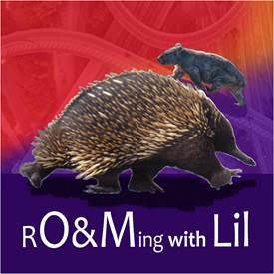
Figure 1 Logo of RO&Ming with Lil

Zooming Together
The first online Zooming Together session was held on 8 May and 49 O&M specialists across Australia and New Zealand participated in this invaluable event! We discussed tele-practice and O&M remote service delivery options, and shared resources available to us.
The next Zooming Together session is planned for July. Watch this space and await an invitation from the Professional Development Committee.

OMAA Position Vacancies

Volunteer IT Advisor
We are in need of an IT advisor to join the OMAA Communications team – someone who knows the difference between a kilobyte, a kilojoule and a killer-whale. We’re setting up the OMAA document register, navigating the back end of the website and needing to manage multiple online communication systems. Apparently cloud storage is not the best place to keep a dripping umbrella!
If you enjoy IT, have some experience with the WordPress platform, and would like to earn points towards COMS recertification, please contact Amy Barrett-Lennard.

New Diagnoses in Tele-practice
COVID-19 is a tough time for health care professionals in hospitals, but it also presents new concerns for technophobes in tele-practice. The following conditions have been diagnosed in Lil’s household:
Techxartisi: dependence on technology, leading to technoedema
Technoedema: the swelling, knotty pile of headsets, cords, devices and webcams that clutter the desk and stop the drawer from closing
Technitis: an acute inflammatory response to technology, causing reddening of language, treatable with liquid medication
Technospasm: sudden involuntary, convulsive movement resulting in splintering demise of devices, and a need to visit Officeworks
Dystechnia: a chronic, disabling syndrome, combining techxartisi, technitis and technoedema
Technokatifeia: a pervasive, gloomy certainty that technology endeavours will never go smoothly
Technothymia: mood dangerously affected by technology, associated with technitis and technospasm
Techmisos: hatred of technology, leading to technospasm with resulting atechnia
Atechnia: (1) absence of technology; (2) bliss; (3) loss of stepcount
Technephoria: unexpected reversal of technokatifeia with symptoms including uprush of joy, irrational smugness and the urge to pop a cork

Please circulate Footwork to anyone who might be interested. If you have queries about the work of OMAA, or would like to subscribe or unsubscribe to Footwork, please contact info@omaaustralasia.com

Read on now for a special one page outline relating to the:

OMAA Online Symposium 2020 Scholarship

OMAA Online Symposium 2020 Scholarship
The inaugural OMAA Online Symposium is taking place on 22 September 2020. The Orientation and Mobility Association of Australasia (OMAA) is offering two scholarships, each sufficient to cover the cost of the event registration.

Eligibility Criteria
- Applicants must be an Ordinary Member of OMAA at the time of application and for the period including the symposium.
- Are in the first 1-5 years of their O&M practice
- Previous recipients of the OMAA-IMC Scholarship are not eligible to apply.
- Members of the OMAA Executive are not eligible to apply.
The OMAA Online Symposium Scholarship aims to assist OMAA members who might not otherwise be financially supported to attend the event.

Process
OMAA Online Symposium applications should be emailed here and include the following details, either in the body of the email or as attachments:
- 200 words (maximum) saying what you hope to gain by attending the OMAA online symposium, and how this will add value to your practice in Australia, Aotearoa/New Zealand or the South Pacific Islands;
- a brief biography (100 words maximum) to introduce yourself, outlining your O&M/GDMI experience.

Selection Panel
Applications will be assessed by a panel. The panel will include the chair of the OMAA Professional Development Committee and at least three members. All Applicants will be notified of the selection panel’s decision via email by 7 August 2020.

Responsibilities of Successful Applicants
- The successful Scholarship Applicants will arrange the registration payment with the OMAA Treasurer and
- write a brief report for the OMAA blog after the event, outlining the highlights of the symposium.

Important Dates
1 June 2020: Applications for the OMAA Online Symposium Scholarship open
1 August 2020: Deadline for the OMAA Online Symposium Scholarship Applications
7 August 2020: All Applicants will be notified of the selection panel’s decision

