Travel Eyes in Egypt

During the month of September 2019, Orientation and Mobility Specialists, Rebecca Dunkley and Metaxia Tsoukatos, travelled to Egypt with the touring company known as Travel Eyes. We went as part of a group that included seven other sighted guides and seven travelers with various levels of vision impairment including two travelers with dual sensory loss (a judo Paralympian who competed in the Sydney Paralympics and the current reigning Scrabble tournament queen of the United Kingdom who competes with sighted players). We travelled in style on the Sonesta Moon Goddess. Many different ancient sites were visited including The Valley of the Kings and Queens (over the hill from the Valley of the Kings), pyramids, tombs of 3 famous rulers from different dynasties, The Sphinx and many temples in places like Luxor, Karnack, Philae and Komombo.

With each site visit led by Caroll Pattison, our Travel Eyes representative and travel director and our local guide Hossam (who has a background in archaeology and participated in archeological digs), the magic contained in the antiquities was uncovered and experienced by all as the hieroglyphics were etched into the ancient sites from time immemorial.

Each site revealed secrets of prior visitors from other ancient civilisations including the Ancient Greeks and Romans like Cleopatra who had a Greek father and Roman lovers. Some of the ancient temples visited are now used by the Egyptian Coptic Orthodox Christians or exist alongside modern day mosques, which sing out the call to prayer five times daily, adding to the magic of Egypt.

We also travelled by felucca, a traditional wooden sailing boat and by camel around the Great Pyramids of Giza and the Sphinx in Cairo.

Many types of Egyptian food was enjoyed by all travelers including a Egyptian party where we all had a chance to dress up traditional Egyptian dress known as Galabayas.

Anyone can share the adventure of Travel Eyes whether they have vision impairment or can see and no experience of travel or human guiding (sighted guiding) is required. Sighted travelers from all over the world pay half the cost of travelers with vision loss from all over the world in exchange for audio description and guiding, a reverse inclusion business model established by founder Amar Latif who is legally blind, a long cane user and Ted talk presenter on “Being limitless”. For further information, please see www.traveleyes-international.com or their Facebook page https://www.facebook.com/TraveleyesLtd/

Travel Eyes are coming to Australia again in February 2020. Rebecca and Metaxia are both looking forward to catching up with Carol and other travelers in Sydney at that time when they will have an opportunity to climb our famous Harbour Bridge.

Here are just a couple of photos from our trip. If you look closely, you cannot see whom the vision impaired and sighted travellers are. This is one of the wonderful things about Travel Eyes – it is all-inclusive and no distinctions are drawn between the various travellers.
Photos – 1) outside the Pyramids, 2) in front of one of the temples, 3) dressed in Traditional dress for our Egyptian Party.

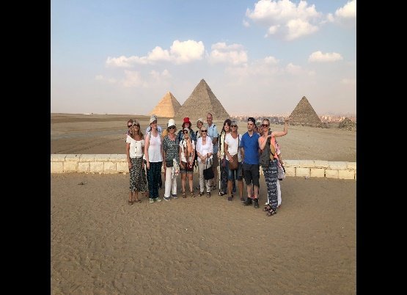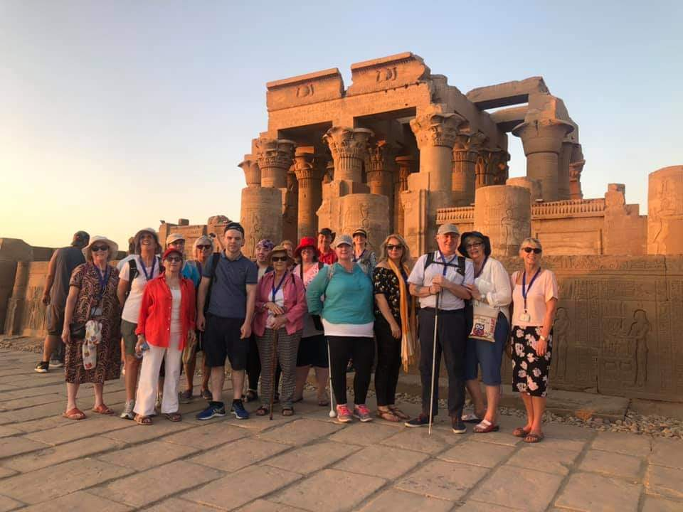

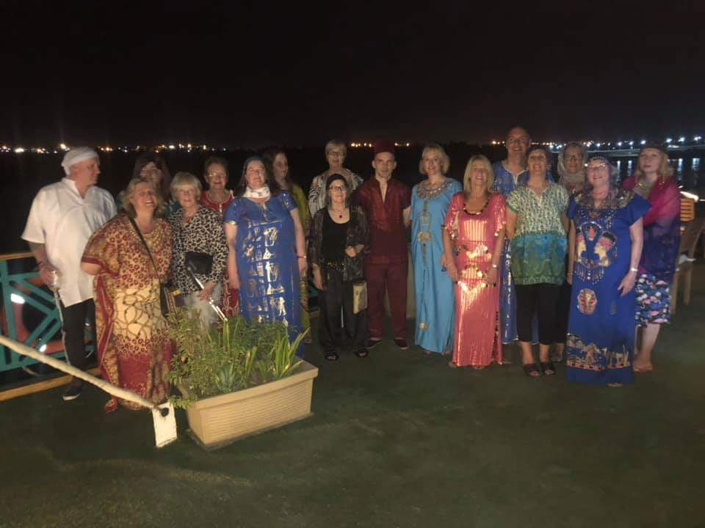

By Rebecca Dunkley and Metaxia Tsoukatos.

