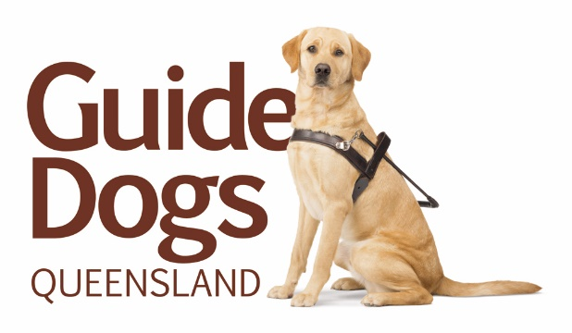

Orientation and Mobility Instructor

An exciting opportunity exists for an experienced fulltime Orientation and Mobility Instructor to join our client engagement team at Guide Dogs Queensland (GDQ).

Our Orientation & Mobility (O&M) service provides O&M to blind & vision impaired adults and children throughout Queensland. Additionally the applicant will have involvement in a range of camps and training programs that GDQ runs for adults and children each year at our head office in Brisbane.

The successful applicant will work alongside a team of skilled health professionals providing support to people who are blind or visually impaired. Your professional input will compliment existing services to provide a holistic approach in enabling clients to participate independently, confidently and safely in daily life.

You will be committed to a person centred approach to working with people with low or no vision and bring excellence, enthusiasm and experience to the role.

This position requires regular travel within an allocated region on an operational basis.

Key selection criteria:
- Tertiary qualifications and experience in the field of Orientation and Mobility.
- Current Open Drivers Licence.
- Experience in working with clients who have a vision impairment.
- A high level of integrity and a strong work ethic.
- Highly effective written and verbal communication and interpersonal skills including working with people who have limited communication ability.
- Excellent time management skills.
- Well-developed problem solving skills.
- The capacity to build rapport and negotiate with a wide range of people from varied backgrounds.
- Ability to work independently, obtain supervision, support and debriefing as required.
- Good judgement and the ability to apply appropriate boundaries to professional relationships.
- Demonstrated ability to be outcome focussed and flexible to changing circumstances and work priorities.
- Mature and professional in approach and presentation.

To learn more about Guide Dogs Queensland, please visit our website at https://www.guidedogsqld.com.au/

To apply, please submit your cover letter addressing how you’d be a great fit for this role and your CV to the HR Team, attention Brittany Gunst at b.gunst@guidedogsqld.com.au.

Please note that due to the high number of applicants for the position, only those who are successful in gaining an interview will be contacted.

