Work with
Guide Dogs
Victoria
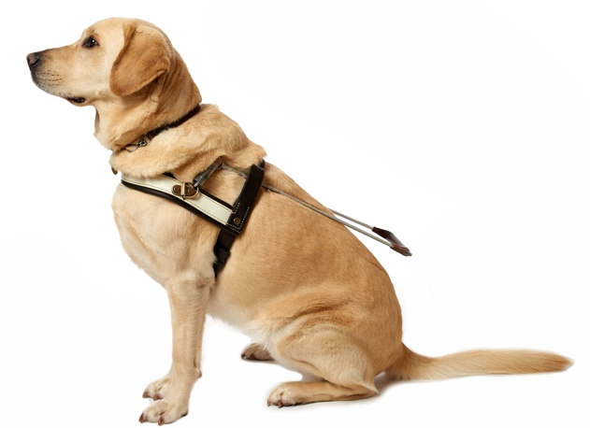
Childrens Mobility Team Leader
Guide Dogs Victoria provides high quality training to maximize the independence of people living with low vision or blindness. Our professional services extend beyond the provision of guide dogs, and include innovative children's mobility programs, orientation and mobility training for adults and people living with an acquired brain injury (ABI), as well as social networking programs to support active community participation. Guide Dogs Victoria is also Australia's most trusted charity and an employer of choice in the disability sector. Our staff enjoy an inclusive and collaborative working environment where talent is recognised and innovation is encouraged.
Guide Dogs Victoria currently has a vacancy for an experienced Orientation and Mobility professional to join our team in the role of Childrens Mobility Team Leader on a full time basis permanent basis, based at or campus located in Kew.
The responsibilities will include:
- Overseeing the caseload of a team of orientation and mobility specialists in the delivery of exceptional mobility services and providing clinical support, coaching and mentorship to the team;
- Oversight of client reporting requirements and ensuring adherence to our quality management systems;
- Maintaining a portfolio of clients;
- Preparing and presenting workshops and education sessions on behalf of the organisation; and
- Working in collaboration across all client and guide dog services, to ensure the delivery of holistic services to our clients.
- Support the development of Early Childhood Services at Guide Dogs Victoria

Requirements for this role:
- Tertiary qualifications in Orientation and Mobility;
- Strong supervisory and coaching skills, and the ability to lead a team of professionals;
- A thorough practical working knowledge of contemporary issues within the disability sector and person centred approaches, together with a strong client focus;
- A commitment to live the Values and Behaviours of Guide Dogs Victoria;
- A strong client and customer focus and a commitment to person centered service practices; and
- A strong alignment with the vision of Guide Dogs Victoria in delivering independence to people with low vision or blindness.
A competitive remuneration package is available commensurate with skills and experience, which includes tax free salary packaging. Applications (including a Cover letter and Resume) should be emailed to hr@guidedogsvictoria.com.au.
Guide Dogs Victoria welcomes applicants who are blind or who have low vision to apply

