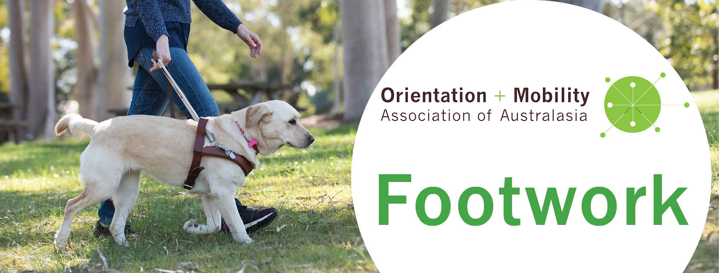
Issue 4, March 2019

Welcome to Footwork, keeping you informed of developments in the Orientation and Mobility Association of Australasia (OMAA).

COMS group submission
We now have 168 people on the COMS (Certified O&M Specialist) group submission list. This is a finite opportunity for O&M specialists who have done agency-based training to apply for COMS, but this door will close with a clang on 31 March 2019. Kathie Zeider, the president of ACVREP is expecting a rush of COMS eligibility applications in the next few months and she assures us she will deal with our Australian/New Zealand applications personally. ACVREP has given those on the list until 31 December 2019 to apply and take the COMS exam. If you haven’t yet put your name on the list, please email lil@deverell.net by 31 March with your name, email address, phone number, O&M qualification and year you completed your training.
Please pass the word around to dormant O&M specialists who might not be aware of this opportunity – those on maternity leave, travelling overseas or who are now working in parallel industries (e.g., access, NDIS). Putting your name on the list doesn’t commit you to applying for COMS but it leaves your option open to do so.
If you have got as far as downloading and reading the COMS Handbook, you might be confused about which category to apply under. Here are some tips:
Category 1 – only for people who have qualified in the USA (otherwise we need a NACES check to show equivalence between ANZ and USA qualifications).
Category 2, Path A – only for people with a university O&M qualification who have also done a COMS supervised internship and completed the ACVREP paperwork. This includes some earlier Massey graduates and about two people in Australia.
Category 2, Path B – everyone else, including graduates from RGDAA, GDNSW/ACT, Blind Foundation, Vision Australia and all Australian/NZ University O&M programs as well as UK training programs. If in doubt, apply through this category.
Please contact Lil Deverell on lil@deverell.net or 0418 370 312 with any queries. Lil will be in touch with those on the list to make sure you understand the application process and have the necessary evidence, including a core domain checklist from OMAA to support your application.

Freelance O&M Specialists (FOaMS)
There is a small but increasing number of O&M specialists in Australia choosing to work freelance. They combine private client work, casual or contract client work for O&M employers, O&M teaching contracts, visiting teacher work in schools, research, and assorted consultancies. There is an opportunity for freelancers to connect via email and meet a few times a year via videoconference for mutual support, sharing opportunities and wisdom learned. If you are interested in joining the FOaMS network contact Kim Pilic (O&M Specialist, Queensland) kimpilic@gmail.com . Thanks, Kim, for agreeing to convene the first gathering.

Research opportunity – wheelchairs and scooters
Interested in further study? Undertaking a higher research degree (Masters or PhD) is a great way to extend your own learning, and is fee-free in Australia. You can investigate a topic that intrigues you while generating practice-based evidence of O&M work (desperately needed by O&M employers), and contributing to the broader O&M body of knowledge. Win, win, win! Lil has been talking with Carolyn Unsworth, a Melbourne based Occupational Therapist (Professor, University of Central Queensland) who is interested in outcome measures and wheelchairs/scooters. We’re looking for a masters/PhD research student to explore and measure wheelchair/scooter use with low vision. If you are (1) keen to do further O&M study/research or (2) curious about this particular project, please contact Lil Deverell on lil@deverell.net or 0418 370 312.

Introducing… the new OMAA Committees, formed in November 2018

The OMAA Professional Development Committee
The objective of the Professional Development Committee is to promote and support COMS recertification for OMAA members. The OMAA is a Registered Provider of Professional Leaning and Education (RPPLE ©) with ACVREP, and as such, OMAA can approve and register local Continuing Education (CE) events with the international RPPLE program. This means that COMS in Australia and New Zealand can earn points towards recertification from local conferences, workshops and seminars that have relevant O&M content. The committee will also scope, review and promote career opportunities / pathways that are relevant to OMAA members. This committee includes:
Ewa Borkowski (COMS) – Professional Development Officer
Ewa is an O&M neuro specialist and the Practice Coordinator O&M at Guide Dogs NSW/ACT overseeing the Professional Development Network for the General stream of O&M, Children and Neurological and initial training of O&M Specialists. Ewa’s role within the committee is to liaise with the OMAA Standards committee, OMAA Executive and ACVREP about continuing professional development.
Kelly Prentice (O&M Specialist)
Kelly has been with Guide Dogs NSW/ACT for 12 years and is currently managing the Kensington Team. She has a sub-speciality in neurological vision impairment and an interest in integrating emerging technology into O&M practice. Kelly’s role within the committee is to develop and proof-read procedures for identifying, approving and registering O&M professional development events.
Paul Garwood (Senior O&M Specialist)
Paul works at Senses Australia (Western Australia) positioned in the Sensory Services team. Paul’s role within the committee is managing the ACVREP RPPLE account. He is developing an internal procedure for the committee to review, approve and register CE events with the RPPLE program, then post the CE events on the OMAA website.
Darren Moyle (O&M Specialist)
Darren has worked in Children’s services with Guide Dogs Victoria and now is at Guide Dogs NSWACT working with all ages. He has a passion for group programs and working with young people. Darren’s role within the committee is to work with Paul to seek, review and approve suitable events for CE points.
Nicola McDowell (O&M Specialist)
Nicola is the Blind and Low Vision endorsement coordinator on the Specialist Teaching Programme at Massey University, NZ. This is one of the programmes that is currently training Developmental O&M Specialists (DOMS) in NZ. She has previously worked as a DOMS and Resource Teacher Vision. Nicola’s role within the committee is to write blogs and promote events and CE opportunities towards recertification.
The committee meets once a month via Zoom and we are currently finding our feet, enjoying getting to know each other and our roles.

The OMAA Professional Standards Committee
The purpose of the OMAA Professional Standards Committee is to establish and maintain (1) minimum standards for entry to the O&M profession, including review of O&M personnel preparation programs for COMS-compliance, (2) a public register of Certified O&M Specialists (COMS) and (3) documents including a scope of practice and grievance procedures, ensuring ongoing provision of quality O&M services by registered professionals. Committee members include:
Lil Deverell (COMS) – Professional Standards Officer
Lil is a freelance O&M specialist, consultant, educator and researcher (Swinburne University, Melbourne). She is also on the Subject Matter Expert Committee for the COMS program. Lil’s role with the committee is to liaise with ACVREP, O&M employers in Australia and New Zealand (ANZ), providers of O&M personnel preparation programs in ANZ, and the OMAA committees and executive. Lil reviews O&M personnel preparation programs for their alignment with COMS requirements, and has been managing the COMS group submission to ACVREP, supported by committee members.
Michelle Sharples (O&M Specialist)
Michelle manages and teaches the Graduate Diploma in O&M at Vision Australia (Melbourne) and represents this program on the Professional Standards committee. Michelle is also involved in the development and review of documentation, policies and procedures for the committee.
Brenda Harris (O&M Specialist)
Brenda manages a mixed O&M caseload, working for Guide Dogs Queensland (Townsville). Her role on the committee is to review the content of O&M personnel preparation programs for their alignment with COMS requirements and she supports the development and review of committee documentation, policies and procedures.
Nancy Higgins (COMS)
Nancy is developing and teaching the New Zealand Diploma in Vision Habilitation/Rehabilitation (Level 7) available through the Blind Foundation, based in Christchurch. She represents this program on the Professional Standards committee, and is also a member of the Subject Matter Expert Committee for the COMS program. Nancy provides the committee with a NZ perspective on O&M standards and their implications in the NZ and international O&M industries.
Bashir Ebrahim (O&M Specialist)
Bashir has been working in the O&M industry since 1988 and is currently delivering client services and leading service development for Vision Australia (Brisbane). Bashir has a keen interest in international O&M services. He supports the development and review of committee documentation, policies and procedures, and considers international O&M standards, particularly in relation to developing countries.
Nicola McDowell (O&M Specialist)
Nicola represents the Massey University O&M training program on the Professional Development Committee, also providing a NZ perspective on O&M standards and their implications in the NZ O&M industry.

The OMAA Communications Committee
The focus of the OMAA Communications committee is to relay information between OMAA members, the executive, and industry stakeholders. Our main means of communication is the quarterly Footwork newsletter, the regular members’ blog, and the OMAA website. The website allows access to information on a variety of O&M related topics; upcoming conferences, job vacancies, professional development opportunities, clinical resources, and so on. We have been working hard on a re-designed website which will offer several new features including a register of certified O&M specialists (“search for an O&M”) and a membership portal where members will be able to review and edit membership details, as well as complete membership payments online. These two features are due to go live in the next few weeks. We are collating content for an online OMAA Museum, hoping this will be added to the website by the end of 2019.
There are four members of the committee:
Amy Barrett-Lennard (O&M Specialist) – Communications Officer
Amy started as an occupational therapist at VisAbility (Western Australia) in 2008, where working closely alongside O&M colleagues inspired her to pursue O&M studies. Since 2010 she has worked with a range of O&M clients in both metro and rural settings. This is an incredibly exciting time in the field of O&M, and Amy endeavours for the committee to provide clear, accessible and timely communication that will help OMAA to navigate the changes ahead. She is looking forward to sitting her COMS exam this year.
Jeremy Hill (COMS)
Jeremy joined Royal Guide Dogs in 1987, worked as a Regional Manager in Western Australia for a couple of years before moving to NSW. Jeremy now manages a team of 12 staff and also specialises in Neurological vision loss and Cortical Visual Impairment in children. He acquired his COMS in June 2018 and now assists on the OMAA Executive Committee in the role of Immediate Past President (he previously fulfilled the role of President for six years). Jeremy is presently compiling photographs, memorabilia and information to create an online Museum of Orientation and Mobility in Australasia on the OMAA website. If you have any interesting historical information or photos, please send them to JHill@guidedogs.com.au
Metaxia Tsoutakos (O&M Specialist)
Metaxia is an O&M specialist with almost a decade of practice in the field and has worked across agencies in Sydney, New South Wales. A professional lifetime of work in the disability and special education sector, both inside and outside classrooms and with lived experience of disability which has contributed to her “wide-beam” approach to service provision. An outspoken advocate for access to information for ALL to make informed choices, facilitate the orientation to services and mobilise access which adds exponential value to the low vision and blindness community. Currently Metaxia’s role in the committee is to bombard Amy with emails including resources for the OMAA website, alongside various colleagues at Guide Dogs NSW/ACT.
Cath Caddis
Cath has been involved in the field of blindness and low vision since 2000. She was inspired by some of the O&M specialists at Guide Dogs Victoria (who shall remain anonymous due to their humility) to undertake the O&M course. Since 2006 she has worked with clients of all age ranges and abilities in metropolitan and rural settings. Currently Cath’s role in the committee is to edit the Footwork newsletter and various other materials as required.
If readers have any feedback regarding website content, or have something to contribute to the next newsletter or blog, please do not hesitate to contact the Communications committee at info@omaaustralasia.com

Please circulate Footwork to anyone who might be interested. If you have queries about the work of OMAA, or would like to subscribe or unsubscribe to Footwork, please contact info@omaaustralasia.com

