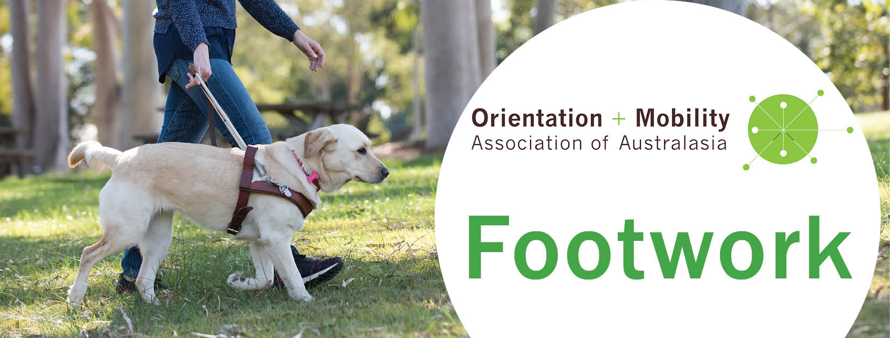
Issue 3, December 2018

Welcome to Footwork, keeping you informed of developments in the Orientation and Mobility Association of Australasia (OMAA).

OMAA restructure
The OMAA Annual General Meeting in November approved a restructure of OMAA to share the workload and improve communication within OMAA and with external stakeholders. As our work towards professionalisation continues, the Board of O&M Australasia (BOOMA) has been reabsorbed into OMAA, and the workload divided between three teams, with a representative from each on the OMAA Executive:
- President: Julia Budd (NZ)
- Vice President: Gayle MacPherson (SA)
- Immediate Past President: Jeremy Hill (NSW)
- Treasurer: Karen Carrigan (NSW)
- Secretary: Vacant
- Communications: Amy Barrett-Lennard (WA), working with Cath Caddis (VIC), Jeremy Hill (NSW), Metaxia Tsoukatos (NSW) and web-designer Monique Lisbon (VIC)
- Professional Standards: Lil Deverell (VIC), working with Bashir Ebrahim (QLD), Brenda Harris (QLD), Michelle Sharples (VIC), Nancy Higgins (NZ) and Nicola McDowell (NZ)
- Professional Development: Ewa Borkowski (NSW), working with Darren Moyle (NSW), Kelly Prentice (NSW), Paul Garwood (WA) and Nicola McDowell (NZ)
The position of OMAA Secretary is still vacant, so please consider whether you know an OMAA member you could nominate for the role. Serving on the OMAA Executive earns you 10 points per year towards COMS recertification (you need 100 points in 5 years). The redesigned website will take care of many previous elements of the secretary’s role relating to managing memberships. The Executive has also been investigating the option of a paid administrator to support the Secretary and Executive.

COMS Group Submission
In Australia, certification is no longer an option but a necessity for any O&M Specialist offering services under NDIS from 2020. In our last issue of Footwork we called for expressions of interest in becoming a Certified O&M Specialist (COMS) as part of a group submission to float the COMS program in Australia and New Zealand. We were delighted to hear from 132 O&M Specialists – nearly half the profession in the ANZ region.
We have sent our group submission to the Academy for Certification of Vision Rehabilitation and Education Professionals (ACVREP) in the USA, which administers the COMS program. It will take about 3 months for the ACVREP Board to consider, and we hope to notify the profession of the outcome, via Footwork, early in 2019. At that time we will contact those who expressed interest, with instructions about what to do next. We will encourage and support people to apply for COMS by June and then take the exam mid-year so that those deemed eligible might be certified by November 2019.
It is worth spending some time over the summer digging in those dusty boxes in the garage to gather and scan evidence of your qualifications and experience (e.g., transcripts, testamurs, internship documentation) and update your CV showing the O&M roles you have served, particularly your direct client work. We will confirm with individuals the list of evidence that each applicant needs, after we hear from the ACVREP Board.
If you are just catching up on COMS and missed getting your name on the group submission list, or perhaps didn’t respond to the call in Footwork 2 (September 2018) because you had added your name to previous lists, simply email the omaasecretary@gmail.com with your name, your O&M qualification (e.g. Masters Renwick, BHSc La Trobe, etc) and the year that you completed your training. We’ll send in a supplementary list to ACVREP before the end of this year.

O&M training pathways in ANZ
While preparing the COMS group submission we unearthed 21 different O&M personnel preparation programs (O&M PPPs) that have been offered since 1971. We invite you to examine the summary spreadsheet of programs at the end of this issue and contact us if you can offer any further information to improve the accuracy of our records.
These rather fragmented O&M PPPs are a testimony to the amazing investment that the agency-employers have made and continue to make in the O&M profession. Without them, the O&M profession wouldn’t have existed, grown, flourished and diversified. However, professionalisation means moving from an agency based, individually sponsored cadetship model to a university/VET sector model designed for accountability, sustainability and the widest possible access to the program; externally accredited while also making best use of industry-based expertise. Cooperation is needed between the OMAA, O&M employers, sponsors and those delivering O&M programs to work out cost effective solutions to our recurring training and staffing crises in the industry.

Workforce planning project
Guide Dogs NSW/ACT is currently leading a National Workforce Planning Project, supported by project partners, Bendelta, focusing on recruitment, retention, organisational resourcing, practice standards and capacity of O&M Specialists (OMSs) and Guide Dog Mobility Instructors (GDMIs). The project is in its early stages of data collection and consultation with key stakeholders including OMAA and Blind Citizens Australia. The outcomes from the project will enable the O&M industry to plan for the future in a sustainable way that ensures continued, quality services provided by qualified O&M professionals, partnering with clients to achieve their goals. The research team wants to include the perspectives of a national cross-section of O&MSs and GDMIs in the next phase of the project. If you’d like to get involved or have any questions, please contact Lisa Dillon (Project Manager/O&M) at ldillon@guidedogs.com.au
We look forward to the recommendations from this research, expected in 2019.

Current O&M personnel preparation programs (PPPs)
The OMAA Professional Standards Committee is working with the providers of our four current O&M PPPs to ensure that they cover the whole body of knowledge and are preparing COMS-ready graduates. You can share these details about existing, comprehensive O&M programs with anyone interested in becoming an O&M Specialist:
- The RIDBC Renwick Centre/Macquarie University program: Master of Disability Studies, awarded by Macquarie University, delivered in collaboration with Australian Guide Dogs agencies, blended learning, with online and face-to-face units. Contact Claire Farrington: Claire.Farrington@ridbc.org.au
- The Vision Australia program: Graduate Diploma of O&M, accredited by Australian Skills Quality Authority (VET sector), delivered face-to-face in Melbourne. Contact Michelle Sharples: omcourse@visionaustralia.org
- The Massey program: Postgraduate Diploma in Specialist Teaching (O&M), awarded by Massey University, NZ; supported by BLENNZ. Contact Nicola McDowell: N.Mcdowell@massey.ac.nz
- The Blind Foundation/CareerForce program: Diploma Level 7, accredited by the New Zealand Qualifications Authority, sponsored by the Blind Foundation. Contact Dr Nancy Higgins: NHiggins@blindfoundation.org.nz

The ongoing conversation about unions
We have been asked by agency CEOs for some clarification on the statement we made in the last Footwork newsletter about union representation.
As we said, O&M is a unique profession that lies between the allied health and education sectors. This uniqueness has led to difficulties in identifying an appropriate union to represent O&M Specialists. The Independent Education Union was willing, recognising that O&M client work is fundamentally a teaching role. However, the right of the IEU to represent O&M Specialists was not recognised by the Fair Work Commission https://www.fwc.gov.au/documents/decisionssigned/html/2018fwc6444.htm Feedback from OMAA members after Footwork Issue 2 has made us aware that O&M Specialists in other states are also in discussions with unions, including the Health Services Union in Victoria.
The OMAA does not endorse (financially support) any one union, but does uphold the right of members to seek union representation when negotiating with employers. While we appreciate that most managers and CEOs endeavour to be approachable, the disparity in power can make negotiations daunting for an individual employee, or employees seeking solidarity. The role of a union is to mediate and advocate on behalf of employees. Union activity seems to intensify during periods of tumultuous change when employees are not feeling heard by their employers, or there is perceived injustice in the workplace, or lack of transparency in negotiating workplace conditions. O&M employers used to take entire responsibility for setting industry standards, recruiting and training personnel, determining employment conditions, and offering professional development, but these responsibilities are now shared with others, including unions.
During times of rapid change, there can be a high drop-out rate, with the risk that key O&M expertise will be lost forever. We encourage employees to appreciate the complexities involved in management decisions, and we encourage managers and HR teams to listen more carefully to staff. Let’s keep the conversation going with patience and grace, aiming for transparency, fair outcomes and an O&M industry that makes employees want to bounce out of bed in the morning, eager to get to work.

Please circulate Footwork to anyone who might be interested. If you have queries about the work of OMAA, or would like to subscribe or unsubscribe to Footwork, please contact omaaustralasia@gmail.com
O&M Personnel Preparation Programs
available in Australia and New Zealand 1971-2018
Green indicates the year that graduates completed their program
‘c’ indicates the year that longer programs commenced or had a student intake
? indicates years where the program was thought to have been available, but we don’t yet have evidence (e.g., graduate names or testamurs)
